4.2 – One to One Functions and Inverse Functions
- A function is one-to-one if any two different inputs in the domain correspond to two different outputs in the range.
- A function is NOT one-to-one if two different inputs correspond to the same output.
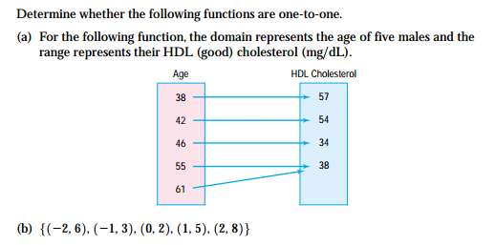

Horizontal Line Test – If every horizontal line intersects the graph of a function f in at most one point, then f is one-to-one.

Finding the Inverse of a function defined by a map
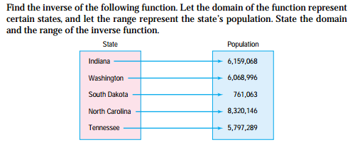
Finding the inverse of a function defined by a set of ordered pairs
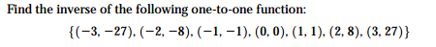

** Domain of f = Range of f⁻¹ Range of f = Domain of f⁻¹
Verifying Inverse Functions
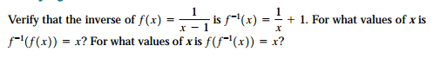

The following graph is one-to-one. Draw the graph of its inverse
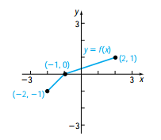
Finding the Inverse Function

